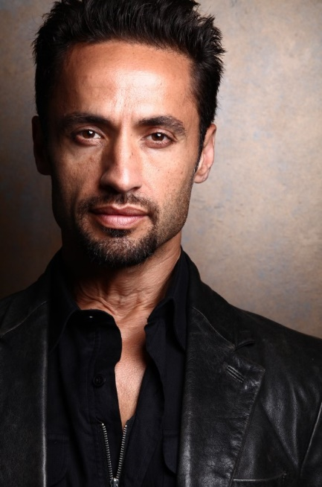
Kamar de los Reyes - GAMBERRO

Conor McGregor = Knock Knock

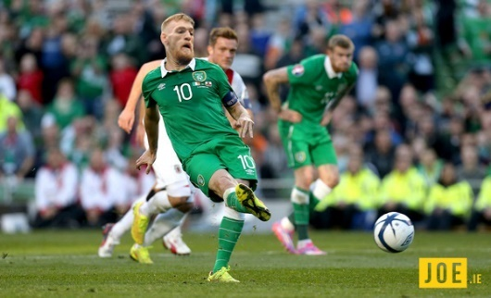

PITCH
Ismael Gamberro -Half Puerto Rican/ Half Cuban Executive for the ACF- Association of Caribbean Football (basically CONCACAF) is ousted after his arrest by the Cuban Government. He is sentenced to a lifetime ban from Caribbean Football. Forced to flee Cuba, Gamberro's only option is to go to Southern California to live with his religious and sage-like Puerto Rican Aunt. There he lives jobless and depressed. Leaders of the American Outlaws (an club comprised of uber soccer fans) finds Gamberro and tries to convince him to help them drum up national support for soccer teams and stadiums across the US. Gamberro thinks US Soccer is a joke and initially rejects the offer. After attending a Portland Timbers game and seeing the fans' enthusiasm, he agrees to help the American Outlaws with their endeavors. For help, he enlists his buddy from Manchester England- Noah Kinsella (aka Knock Knock), an ex Footballer who is notorious for starting fights.

Gamberro and Knock Knock turn US Soccer upside down with their orchestrated brawls, social media tactics and under the table endorsements from local breweries and marijuana dispensaries. Gamberro has to ward off Big Beer- who tries desperately to sabotage Gamberro's affords to promote U.S.Soccer because they cannot monopolize profits; and a division of the INS, assigned to watch Gamberro under the guise of monitoring corruption in Soccer, but whose ulterior motives are revealed as the series progresses. The INS wants to use the Soccer Clubs as a Safehouse. They plan to distribute P-1 Visas to allies/spies residing in restricted Countries. Because the growing popularity of US Soccer, it would be totally plausible that players would be recruited from other countries. CIA in conjunction with the INS not only wants to retrieve assets from terrorist regions, but needs to protect those assets from retribution from terrorist sympathizers already in the States. The Soccer Clubs are a perfect front.The TV Series follows Gamberro and Knock Knock as they make soccer games nightly news- eventually becoming the Over Lords of US Soccer.

The Gamberro Series is narrated by Gamberro's teenage daughter, whom he hasn't seen since her birth in Miami, Fl. Throughout the series, Gamberro wrestles with his conniving, manipulative, rico-savo persona vs redemption and becoming a respectable business man with integrity. The fate and future of U.S. Soccer rest with that decision.

The Series is shot in the vain of Snatch and Trainspotting. There are times when characters speak Spanish and (possibly Gaelic). Gamberro, which is Latin for Hooligan is well dressed and well mannered. Something he learned from his Puerto Rican Father. The manipulation and business savviness is what he learned from his Cuban Mother. Knock Knock (Noah Kinsella - Gaelic slang for 'brawler') was a footballer and sports commenter until his belligerent and crass ways derailed both those careers. (Think Mickey from Snatch with tattoos and a cigarette hanging out his mouth). Knock Knock also have an infinity for Black Women. This gets him in trouble often because he is always suspects someone of racism when he's just a jerk. Gamberro and Knock Knock seem like an unlikely pair but they share a sincere love for Football. They will be seen often playing one on one soccer.

LOGLINES

Ousted Caribbean Futbol Exec finds new adventure with U.S. Soccer.

Exiled Caribbean Futbol Expert, along with his belligerent Irish ex-Futbol star friend, take over U.S. Soccer.

Defuncted Caribbean Futbol Exec takes over U.S. Soccer and makes it the most watched game in the world.

Broke and exiled, Caribbean Futbol Exec, along with his bruge Irish side kick, finds new life in U.S. Soccer.

Exiled to the United States, a defunct Caribbean Futbol Exec finds new life with U.S. Soccer.

Banished to the U.S., a renowned Caribbean Futbol Tactician uses his unorthodox expertise to boaster U.S. Soccer.

Ostracized Cuban/Puerto Rican Futbol Executive climbs out of despair to become the King of U.S. Soccer.

Ismael Gamberro | Main Character | Gamberro is Latin for Hooligan. Gamberro has a Cuban Mother is dead and a Puerto Rican father. He is a self-made man and his wealth extends to both Puerto Rico and Cuba. He hides his poor beginnings by dressing very well and adhering to Gentlemanly manners.
Noah Kinsella aka Knock Knock | Friend/Side Kick | Kinsella means Mick, drunkard, brawler. Knock Knock has been a Footballer all his life but his professional career was cut short (not sure why). He drinks to fight because he likes to fight. He is thin but muscular and packs a powerful punch much like Mickie from Snatch. Knock Knock has an infinity for Black Women. When he gets to the Southern California, he eyes a Fitness Instructor and unsuccessful tries to woo her.

Project Title: GAMBERRO (Hooligan)
Genre: Sports Drama
Opening Image – Holding Cell in Cuba. Gamberro is being beaten up. Daughter narrates throughout the show in both Ingles and Spanish.
Set-up: Gamberro a Half Puerto Rican/Half Cuban Sports Executive, loses everything. Goes to Southern California.
Theme Stated (happens during the Set-up) – Guy with a problem
Catalyst – Gamberro is banned from ACF (Association of Caribbean Futbol) for life due to illegal behavior.
Debate – What will Gamberro do for a career when Futbol is life?
Break Into Two (Choosing Act Two) – The American Outlaws track Gamberro down and try to convince him to help them increase national recognition for US Soccer.
B Story – Gamberro has a daughter he hasn't seen since she was born and family members he hasn't spoken to including his Puerto Rican Aunt, whom he now lives with.
The Promise of the Premise – Gamberro first refuses the Outlaws offer because US Soccer is a joke around the world, but decides to attend a Portland Timbers game and after seeing the game and the enthusiasm of the fans he decides to help the American Outlaws. He enlist the help of his friend - an ex Irish Footballer from Manchester, Noah Kinsell aka Knock Knock, who is notorious for brawling.
Midpoint –
Bad Guys Close In : The DOJ finds out (through Gamberro's acquisition of an Obama phone- he's broke so) that Gamberro is getting involved in US Soccer. They send an Female Agent to let Gamberro and Knock Knock know that they are watching them.
All is Lost: (not revealed in Pilot episode but in later episodes) Gamberro has to fend off big Beer (Anheuser-Busch, Heineken, SABmiller, etc), who doesn’t like that Gamberro cuts deals with local breweries and marijuana dispensaries to help fund US Soccer.
Dark Night of the Soul: Gamberro has to throw a game. Big Beer threatens to get Govt to extradite Gamberro back to Cuba to face corruption charges.
Finale – Gamberro calls the local Spanish station in Portland to make sure they are at the right place when he and Knock Knock start a massive brawl at the Timbers game.
Final Image – There are hits all over Social Media of brawl at the US Soccer game.

IDEAS
Knock Knock falls in love with two pit bull puppies that he rescues from dog fighters. He named them Morgan and Monique but calls them his Mean Bitches.

Gamberro is trying to make a deal with some people that tells him to meet them at their place where they have dog and cock fights. Knock Knock thinks the practice is disgusting and refuses to participate. He and Gamberro argue over the issue and Knock Knock stays. The losing dog dies. When the men go to take it back to its kennel to be destroyed later, they hear yelping. The owner of the dog tell him that she has some pups. Knock Knock states that part of the deal is they have to give him the 2 pit bull puppies.
Knock Knock is in a Detroit strip club and meets a dancer. She tells him her passion is dancing and she dances for her boyfriend's soccer team. Knock Knock is curious and goes to the game. There is a female Beat Boxer who goes on before the game. Then the dancers. Knock Knock convinces Gamberro to get some backing to form a Detroit Soccer Club. Gamberro is already there with his Aunt and a Christian Business Women's Conference. His intention all along was to secure investors. Most women are greeter as Dr. So So, Evangelist, Prophetess, Bishop, etc.

Knock Knock coincidently meets Mother McNair and befriends her. He doesn't know that she's the top dog, celestial decision maker of everything Churchie in Detroit. She is the Mother of the biggest Mega Church in Detroit and they have several satellite churches around the US and the world. She takes a liking to Knock Knock and decides to great he and Gamberro the money to form a Detroit Soccer Club. - on the condition that the Dancers stop stripping. They compromise.

The first Detroit game, the dancers come out to the music of the Female Beat Boxer. This starts a trend and more Soccer Clubs want to have their own Dancers.

INTRODUCTION : When Knock Knock gets the call from Gamberro to come to the States, he's in a club. Carl Cox is DJ. Knock somehow gets into a fight.

