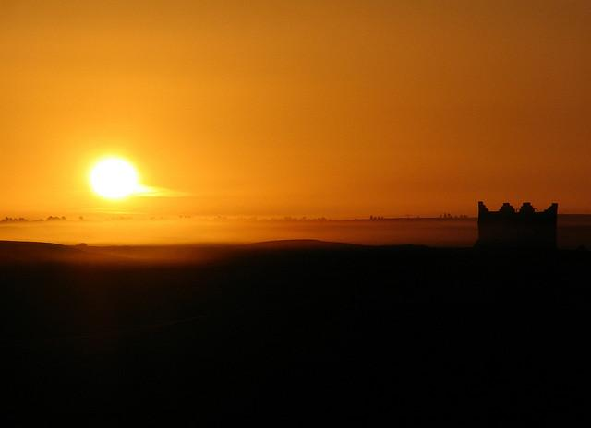
THE INHEIRTANCE
TV Miniseries Series Bible
By Monique McCartha

A PROMISE WORTH CONQUERING FOR

Logline
JOSHUA, the Successor to Moses, overcomes depression and self-doubt to become the Greatest Military General in Biblical History by conquering the Promise Land.

Setting
1446 BC. Middle East- Wilderness of Sinai and Moab.
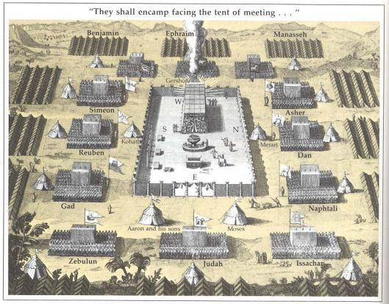

Pitch

God kills Moses. After the slaves are freed from Egypt, the parting of the Red Sea and 40yrs spent in the desert, Moses dies without seeing the Promise Land. All other versions end there. THE INHERITANCE is an adaptation of the Book of Joshua, which finalizes the Exodus story. This dramatic miniseries set for Basic Cable, will be a visual mixture of Exodus meets Dune and Conan the Barbarian. It will show how the Children of Israel conquers Canaan and lives under God's laws and commandments.

THE INHERITANCE begins with Moses going up to Mt. Nebo to die. Before he dies, Moses meets God in the physical, and an Angel escorts Moses to a celestial viewing post to show him the land promised to Abraham, Isaac and Jacob. His Successor, Joshua, grief stricken over Moses’ death, goes into seclusion and leaves the People without a leader. Using his wife Shirah, God convinces Joshua to lead and take Canaan by force. Convening with his War Council, consisting of Caleb, Eleazar the Priest, Noah-Army Colonel, and the other Judges of the 12 Tribes, Joshua sends the spies and enacts his silent marching plan to conquer Canaan. But Joshua is not alone. God sends a fierce Angel, only Joshua can see, who helps the People by battling demonic forces in an invisible realm. (God randomly chooses who can see this realm).

Through flashbacks and present accounts, THE INHERITANCE brings the viewer into the Camp of Israel and their unique customs and laws. Because of the 40yr wandering, the people are relatively young - the eldest being 57 (save Joshua and Caleb). They have adopted a policy that all children are trained for warfare. For the remainder of the series, Joshua leads the People and his army of foot soldiers into unknown territories to purge them of their inhabitants. The spies will be sent, Rahab will be spared and the Walls of Jericho will come down. However the miniseries will go beyond traditional accounts and show a people engaged in war, visible and invisible.

Each 1hr episode, using a multicultural cast, will show how the varying characters fall either on the side of the Protagonist = Courage and Obedience, or on the side of the Antagonist = Disobedience and Unbelief.

CHARACTERS
Joshua  Shirah  Caleb  Eleazar  Salmon  Rahab  Ad daakin  Noah  Milcah  Mahlah  Achsah  Othniel  Achan  Devorah  Moses  I AM  Commander of the Army of the Lord | Tribes  Reuben  Simeon  Levi - Priest (no land given)  Judah  Dan  Naphtali  Gad  Asher  Issachar  Zebulun  Joseph - (Manasseh and Ephraim)  Benjamin

Joshua | Tribe of Ephraim, Moses right hand since Egypt, Successor and General to all the Armies of Israel. Keeper of Joseph's bones.
Shirah | Tribe of Levi. Joshua's wife
Devorah | Granddaughter to Joshua. About 4-5yrs old.
Caleb | Judge of the Tribe of Judah. One of the original survivors of Egypt and 40yr wandering. Loves women. Have many children.
Eleazar | Tribe of Levi. Priest, son of Aaron. OCD – keeps to himself and everything around him immaculate. Doesn't like to touch people.
Salmon | Tribe of Judah. Nephew to Caleb. Lieutenant under Joshua. Tall, strong, handsome, everyone's favorite, blah, blah, blah
Ad daakin | Tribe of Levi. Grandson to Moses. Relative of Joshua. Scholar and helps keep the scrolls of Moses. Studies different cultures and is multi-lingual. Dark skinned awkward young man.
Rahab | Canaanite Innkeeper. Former Prostitute. Has Egyptian heritage. A woman in her 30s. Sold into sex slavery as a child.
Achan | Tribe of Judah. Soldier and good friend of Salmon. Jokester, married with children.
Noah | Tribe of Manasseh. Colonel in Israelite Army. Daughter of Zelophad - who had no sons. Rescued by Joshua from the Amalekites as a young girl. Expert in weaponry and battle gear. Woman in her 40s-50s.
I AM | God, YHWH, Jehovah,
Commander of the Lord's Army | Male Angel. Instructs Joshua in war tactics. Fights with Demonic Forces in the Invisible Realm. Wears gold & Silver in his armor. Has a sword that looks like its pure Gold.
Milcah | Current Judge of the half- tribe of Manasseh. Daughter of Zelophad -Sister of Noah and Mahlah.
Mahlah | Tribe of Manasseh. Daughter of Zelophad - Eldest Sister to Noah and Milcah. Known throughout Israel for her extraordinary healing capabilities using plants and herbs. Born with a deformity (possible missing arm or cerebral palsy) due to mother being bitten by a snake while pregnant during the desert wandering. Resides mostly with the other half tribe of Manasseh, Reuben and Gad.
Achsah | Tribe of Judah Daughter of Caleb. Expected to marry Salmon.
Othniel | Tribe of Judah. Mean, swears often and not conventionally handsome. Follows the law only because he has to not because he wants to. Refuses to participate in military services.

Episode Trends and Notes:
- There will be at least 7 episodes.
- Blood being spilled on the ground occurs in every episode. Each episode will have something being killed, either an
animal being sacrificed on a brutal killing.
- The Inheritance is violent and the battles can get extremely violent and unpleasant.
- God's law is important and the People have been basically separated from most contact with other people, so they will take their customs and the law extremely seriously.

EPISODES SYNOPSIS

SUCCESSOR:
Moses and Joshua go to Mt. Nebo where God meets Moses and employs an Angel to show Moses the land he promised Abraham, Isaac and Jacob. God kills Moses and sends Angels to carry his body away, which Joshua witnesses. Joshua goes into seclusion, where he relives running after Moses in his dreams. His wife, granddaughter and Caleb try to coax him out of his depression and seclusion. When God begins to speak to Joshua thru his wife Shirah and the Priest Eleazar, He steps up to his leadership role. Joshua begins to strategize on taking Canaan. He and the Heads of the tribes send two spies to Jericho: One soldier and one scholar. The Reconnoiters survey the city, its wall, guards, water system, traffic and political system. The Spies discovered when they refuse to eat food that is restricted by their law. Rahab, the Innkeeper, hides the Spies and saves the men by sneaking them out of a secret opening in the wall from her inn, only after they agree not to harm her or her loved ones. She tells them to hide in the hills instead of going back to the Israel Camp. Salmon is obviously attracted to Rahab. The King, who had been warned, sends his guards to collect the Spies. They search Rahab’s inn and the city but are unsuccessful. The King sends for Rahab's arrest. Before she lives, she instructs her workers to gather her family that live around the city and make them to remain her house until she returns. End of Episode One

THE PROSTITUTE:
Rahab is interrogated by the King of Jericho. She is told that she will be set free in exchange for a night with a little girl, who works in her Inn. The 2 Spies remain in the Hills of Jericho for 3 days, while the Judges contemplate what to do if they do not return. Flashbacks of the Egypt Exodus, and Rahab's family history including her Egypt ties and how she comes to believe in the Hebrew God. Flashbacks of being sold into sex slavery and growing up in Jericho. The Soldiers return to the Camp from the hills. End of Episode

CROSSING & CIRCUMCISTION:
Joshua begins to read the scrolls Moses has written often. He leads the people across the Jordan River and the miracle that solidifies his authority as God's chosen leader. The Priest Eleazar orders all men born after the 40yr curse should be circumcised. The Commander of the Army of the Lord appears to Joshua, and Joshua becomes aware of an invisible realm where malevolent forces reside. The Angel gives Joshua his orders to circle the city. The Judges reject the idea initially but gets on board with preparing for war. The Manna stops. End of Episode.

Jericho:
King of Jericho declares that the city is under siege. All gates are locked up and Rahab remains in custody. As the Angel instructs, Joshua leads the people to circle the city. On the 7th day, the wall falls down. Rahab escapes from custody and arrives at her Inn which is miraculously untouched by the earthquake. The Israelites storm the city and kill every person there, except those in Rahab's house.

Achan's Sin:
Reeling from their victory at Jericho and over confident, Joshua quickly plans to take the city of AI. They lose and have to withdraw. Ad daakin the Scholar dies in the fight. Angry and embarrassed, Joshua goes off to yell at God. The Angel tells him that it's because of disobedience that they lost. The Priest cast lots to figure out who is the culprit. The lot falls to Achan's house. Joshua decides to stone Achan and his family. Salmon pleads for Achan's life unsuccessfully. He also struggles with his feelings for Rahab. They burn their bodies and Israel regroups and annihilates AI in battle. End of Episode.

The Gibeon Deception:
The Kingdom of Gibeon, knowing they are next on Joshua's list of destruction, concocts a plan to deceive them to save the city. Joshua and the Judges make a covenant with Gibeon who disguises themselves as poor Bedouin's from the far east. Rahab and her family know who they are and try to warn Joshua. Because of prejudice, her warnings are rejected. Once Joshua finds out the truth, he asks God if they can still kill them. God refuses because of the covenant he made. Gibeon is then threatens by other kingdoms because of their treaty and Joshua has to fight an army of epic proportion. The Israel Soldiers are outnumbered 10-1. End of Episode

Sun Stands Still:
The Israelites are fighting the massive armies lead by 5 Kings. The Kingdom of Gibeon fights alongside them. Joshua commands the Sun to stand still to give them more time to destroy the army. The Sun remains in the sky well past the time it should have. The Israelites are again victorious. End of Episode

SERIES BIBLE STRUCTURE

Title of Show | THE INHERITANCE (working title)
Created by | Monique McCartha
Genre (s) | Biblical Drama
Length of Show | Mini Series -1hr
References | Exodus meets Dune, Conan the Barbarian and Contact
Tag Line | Courage is all you need to conquer a nation
Log Line | Joshua overcomes depression and self-doubt to conquer the Promised Lands and becoming the greatest Military General in Biblical History.
Series Synopsis | Through flashbacks and present accounts, THE INHERITANCE brings the viewer into the Camp of Israel and their unique customs and laws. Because of the 40yr wandering, the people are relatively young - the eldest being 57 (save Joshua and Caleb). They have adopted a policy that all children are trained for warfare. For the remainder of the series, Joshua leads his army of foot soldiers into unknown territories to purge them of their inhabitants. The spies will be sent, Rahab will be spared and the Walls of Jericho will come down. However the miniseries will go beyond traditional accounts and show a people engaged in a visible and invisible war.
Character List/Description | Attached
Episode Synopsis | THE INHERITANCE begins with Moses going up to Mt. Nebo to die - only after meeting God in the physical, and after an Angel takes Moses to a celestial viewing post to show him the land promised to Abraham, Isaac and Jacob. His Successor Joshua, grief stricken, is in seclusion and leaves the People without a leader. Using his wife Shirah, God convinces Joshua to lead and take Canaan by force. Convening with his War Council, consisting of key characters Caleb, Eleazar the Priest, Noah and the other Judges of the 12 Tribes, Joshua sends the spies and enacts his plan to conquer.
Visual Arts | Desert setting, possibly Yuma, Sonaran or another southwestern desert locale.  Contact film similarities: The beginning scene of Moses' encounter with I AM and the angel, and the Angel taking him to a celestial post is reminiscent of the scenes from Contact when Ellie falls through the wormhole and encounters the alien.  DUNE film similarities: Think Arrakis sand hills in some scenes. Desert fitted suits will replace armor and the Israelite army will parallel the vastness of the Freman army.  Conan the Barbarian film similarities: Valeria style of sword play for the Noah character and most of the female fighters. Also when she comes back from Valhalla, this concept can be used when we first see the Commander/Angel appear before Joshua. Scenes in Jericho will parallel Thulsa Doom's temple orgy scenes.
Episode Outlines | Attached

VISUAL ART CONCEPTS/IDEAS

Desert/Wilderness of Camp

Israelite Army Suits
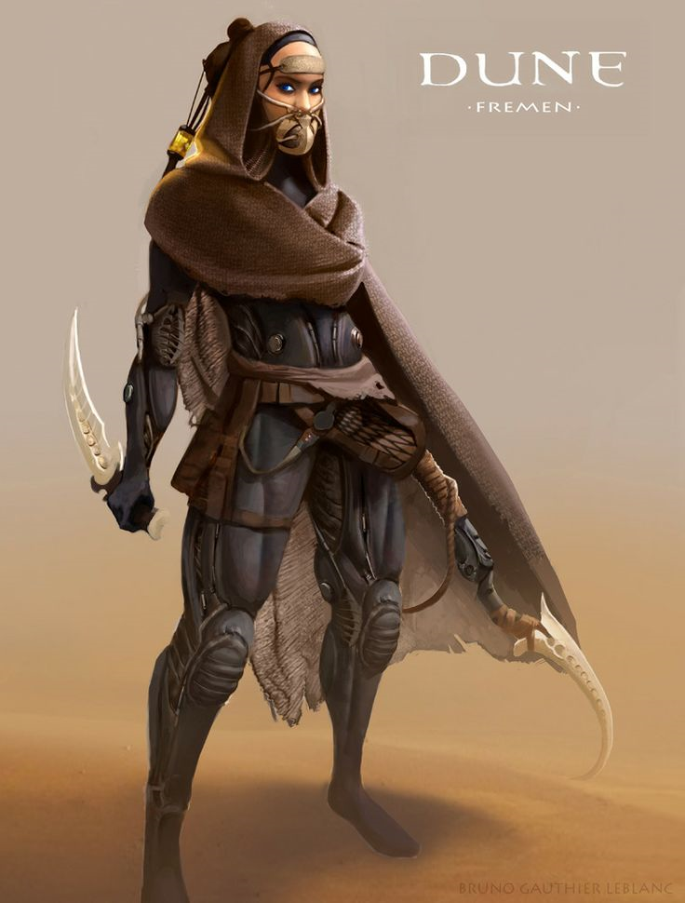

Israel Army
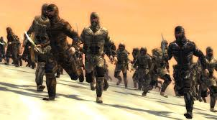

Commander of the Army of the Lord
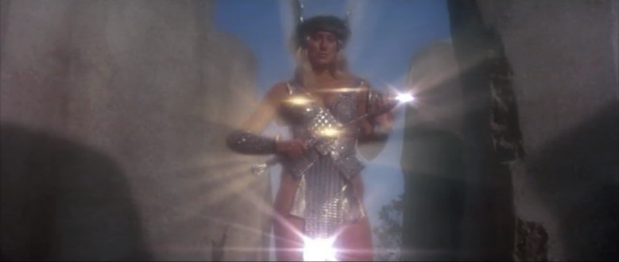

King of Jericho
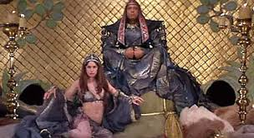

Casting Ideas
Joshua -

Shirah –

King of Jericho – Dave Gahan

King of Gibeon -Russell Wong

